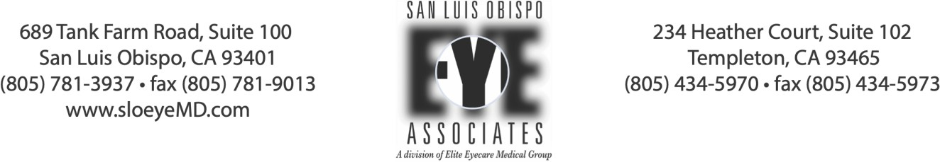

Signature on File, Assignment of Benefits, & Financial Disclosure and Agreement

Patient Name | Date of Birth

- MEDICARE: I request that payment of authorized Medicare benefits be made on my behalf to San Luis Obispo Eye Associates, for services furnished to me by San Luis Obispo Eye Associates. I authorize any holder of medical information about me to release to the Centers for Medicare and Medicaid and its agents any information needed to determine these benefits or the benefits payable for related services. I understand my signature requests that payment be made and authorizes release of medical information necessary to pay the claim. If other health insurance is indicated in Item 9 of the HCFA 1500 form or elsewhere on other approved claim forms, my signature authorizes releasing the information to the insurer or agency shown. San Luis Obispo Eye Associates accepts the charge determinations of the Medicare carrier as the full charge, and I am only responsible for the deductible, coinsurance, and all non-covered services. Coinsurance and deductible are based upon the charge determination of the Medicare carrier.

- MEDIGAP: I understand that if a MediGap policy or other health insurance is indicated in Item 9 of the HCFA 1500 form or elsewhere on other approved claim forms, my signature authorizes release of the information to the insurer or agency shown. I request that payment of authorized secondary insurance benefits be made on my behalf to San Luis Obispo Eye Associates if possible, or otherwise to me.

- RELEASE OF INFORMATION: San Luis Obispo Eye Associates may disclose all or any part of my medical record and/or financial ledger, including information regarding alcohol or drug abuse, psychiatric illness, communicable disease, or HIV, to any person or corporation which is or may be liable to under contract to San Luis Obispo Eye Associates for reimbursement for services rendered, and to any health care provider for continued patient care. San Luis Obispo Eye Associates may also disclose on an anonymous basis any information concerning my case, which is necessary or appropriate for the advancement of medical science, medical education, medical research, for the collection of statistical data or pursuant to State or Federal law, statute or regulation. A copy of this authorization may be used in place of the original.

- OTHER INSURANCE: I understand that San Luis Obispo Eye Associates maintains a list of health care service plans with which it contracts and that San Luis Obispo Eye Associates has no contract, expressed or implied, with any plan that does not appear on the list. The undersigned agrees that I am individually obligated to pay the full charges of all services rendered to me by San Luis Obispo Eye Associates if I do not belong to a plan that appears on this list. A list of health plans with which San Luis Obispo Eye Associates contracts is available from the business office.

- NON-COVERED SERVICES: I understand that San Luis Obispo Eye Associates' contracts with health care service plans (i.e., HMOs, PPOs) relate only to items and services which are “covered” by the health care service plans. Accordingly, the undersigned accepts full financial responsibility for all items or services, which are determined by the health care service plans not to be covered. Examples of non-covered services include, but are not limited to, services not specified as being covered in the patient’s contract with a health care service plan or in the benefit summary the health care service plan furnishes to the patient; and treatment or tests not authorized by the health care service plan. The undersigned agrees to cooperate with San Luis Obispo Eye Associates to obtain necessary health care service plan authorizations.

- FINANCIAL AGREEMENT: I agree that in return for the services provided to the patient by San Luis Obispo Eye Associates, I will pay my account at the time service is rendered or will make financial arrangements satisfactory to San Luis Obispo Eye Associates for payment. If an account is sent to an attorney for collection, I agree to pay collection expenses and reasonable attorney’s fees as established by the court and not by a jury in any court action. I understand and agree that if my account is delinquent, I may be charged interest at the legal rate. Any benefits of any type under any policy of insurance insuring the patient, or any other party liable to the patient, is hereby assigned to San Luis Obispo Eye Associates. If copayments and/or deductibles are designated by my insurance company or health plan, I agree to pay them to San Luis Obispo Eye Associates at the time of service. However, it is understood that the undersigned and/or the patient are primarily responsible for the payment of my bill.

- NOTICE OF SPECIAL FEES NOT COVERED BY MEDICARE, INSURANCE COMPANIES OR HEALTH PLANS: Please note the following medical administrative services which are beyond the scope of a standard office visit and for which we charge an additional fee as outlined in the schedule below. These services are not covered by Medicare, health plans, HMO’s, PPO’s or medical insurance and are therefore due and payable at the time of service.

  - MISSED APPOINTMENTS: If you are unable to make a scheduled appointment, please call our office at least 24 hours in advance so that we may offer your appointment time to another patient. Failure to provide 24 hour advance notice of cancellation will incur a $50.00 fee.
  - COMPLETION OF FORMS: Completion of forms, reports and letters will incur a flat fee of $25. Common reports and forms for which these fees are charged include but are not limited to DMV, State Rehab, Certificates of Legal Blindness, Handicapped permits, California Telephone Access Program (CTAP), excuses from jury duty, travel reimbursements, FAA Flight Physicals or eye exams, most school forms and other similar forms.
  - MEDICAL RECORD FEES: Copying and mailing of medical records (whether requested by the patient, hospital or another physician) or electronic copies of records (scanned images to CD) will incur a flat fee of $25.00.
NOTIFICATION OF THE OPEN PAYMENTS DATABASE: The Open Payments database is a federal tool used to search payments made by drug and device companies to physicians and teaching hospitals. It can be found at https://openpaymentsdata.cms.gov.

By signing below, I acknowledge that I have read and understand the foregoing financial policy and fee schedule.

Beneficiary Signature or Authorized Party | Date

021723

